
Welcome to Cub Scout Pack 1!

Our pack at __________ is a fun, active unit. We are looking forward to you and your child joining us! There will be activities each month that are exciting for the entire family.
Here are some upcoming activities:
September 17: Pack Meeting, The Amazing Park down the street
September 19: Fishing Derby, Saukenauk Scout Reservation
October 15: Pack Meeting, That one place down the street building
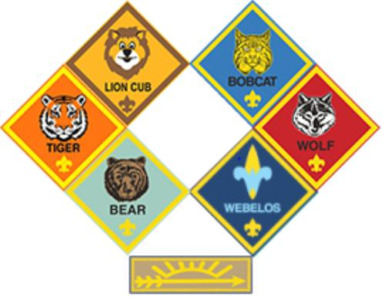
Cub Scouting has age specific programs, and each grade is part of a “Den”. Den Meetings are as follows:

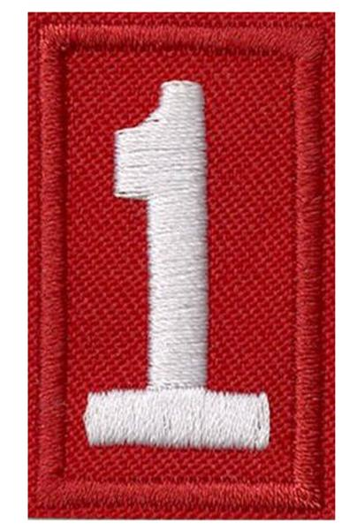
Kindergarteners (Lions) Meetings are TBA
1st Graders (Tigers) Meet the 2nd and 4th Tuesday’s of each month from 6-7 PM
2nd Graders (Wolves) Meetings are TBA
3rd Graders (Bears) Meet the 2nd and 4th Monday’s of each month from 6-7 PM
4th Graders (Webelos 1) Meet the 2nd and 4th Tuesday’s of each month from 6-7 PM
5th Graders (Webelos 2 Meet the 1st and 3rd Tuesday’s of each month from 6-7 PM
What is the cost?
Cost thru December 2020 is $70, which includes registration, costs for advancement, and pack t-shirt. If you want to pay for an entire Scouting year (through December 2021, the cost is $160. This does not include uniform or other activities throughout the year. The pack participates in 2 fundraisers throughout the year. Both can help your Scout pay their way through an entire year of Scouting. The council also provides scholarship opportunities.

Questions? Contact Scout Volunteer at 555-555-5555 or email: Scouter4life@bsa.com

